University of Science and Technology
- Wrocław-



LABORATORY 2: UTILIZING SOFTWARE FOR BUSINESS PROCESS MODELING

SUPPORT FOR IT PROJECT MANAGEMENT
2025/2026
Teacher: Piotr Zabawa
Student: Álvaro Puebla Ruisánchez 293867

Table of Contents
Table of Contents 2
1. Software Overview 3
1.1 Name and Purpose 3
1.2 Key Functionality 3
1.3 Why Lucidchart Was Selected 3
2. Performed Tasks 4
2.1 Task 1 - Morning Routine Flowchart 4
2.2 Task 2 - Preparing Tea Flowchart 5
2.3 Task 3 - Post-Murder Decision Flowchart 6
3. Summary 7
3.1 Software Suitability Assessment 7
3.2 Evaluation of Software Functionality 7
3.3 User Interface Evaluation 7
3.4 Evaluation of Other Software Attributes 7

1. Software Overview

1.1 Name and Purpose
Lucidchart is a web-based diagramming and visual communication platform developed by Lucid Software. Its primary purpose is to enable users to create, share, and collaborate on a wide variety of diagrams, including flowcharts, business process models, org charts, network diagrams, and UML diagrams. In the context of this laboratory, Lucidchart was selected as the tool for modeling business processes due to its accessibility, intuitive interface, and robust feature set.

1.2 Key Functionality
Lucidchart provides the following core functionalities relevant to business process modeling:
- Diagram Creation and Editing: A full-featured drag-and-drop canvas supporting flowchart symbols, BPMN elements, and custom shapes.
- Save and Load Functionality: Diagrams are stored in the cloud and can be saved locally as .lucid, .pdf, .png, or .svg files.
- Version History: Users can view and restore previous versions of any diagram at any time.
- Collaboration Features: Real-time multi-user editing sessions, comments, and sharing links are supported.
- Free Tier: Lucidchart offers a permanent free plan (up to 3 diagrams) with no time limitation.
- Browser Version: Lucidchart operates entirely in the browser; no installation is required.
- Diagram Templates: A library of pre-made templates is available for common process types.

1.3 Why Lucidchart Was Selected
Lucidchart was chosen over competing tools such as SAP Signavio, IBM Blueworks Live, ADONIS, Microsoft Power Automate, and Bizagi based on several practical criteria. It is the only evaluated tool to offer a fully free tier with no time constraint, making it suitable for students without financial burden. Its browser-based nature removes any installation barrier. Additionally, its interface is widely regarded as intuitive and fast to learn, and some members of the course cohort already had prior familiarity with the tool from earlier semesters.

2. Performed Tasks

2.1 Task 1 - Morning Routine Flowchart
Task description: Create a flowchart broadly describing a morning routine. The flowchart must include: pressing the snooze button repeatedly until deciding it is time to get up, picking an outfit, and choosing breakfast based on mood or available ingredients.
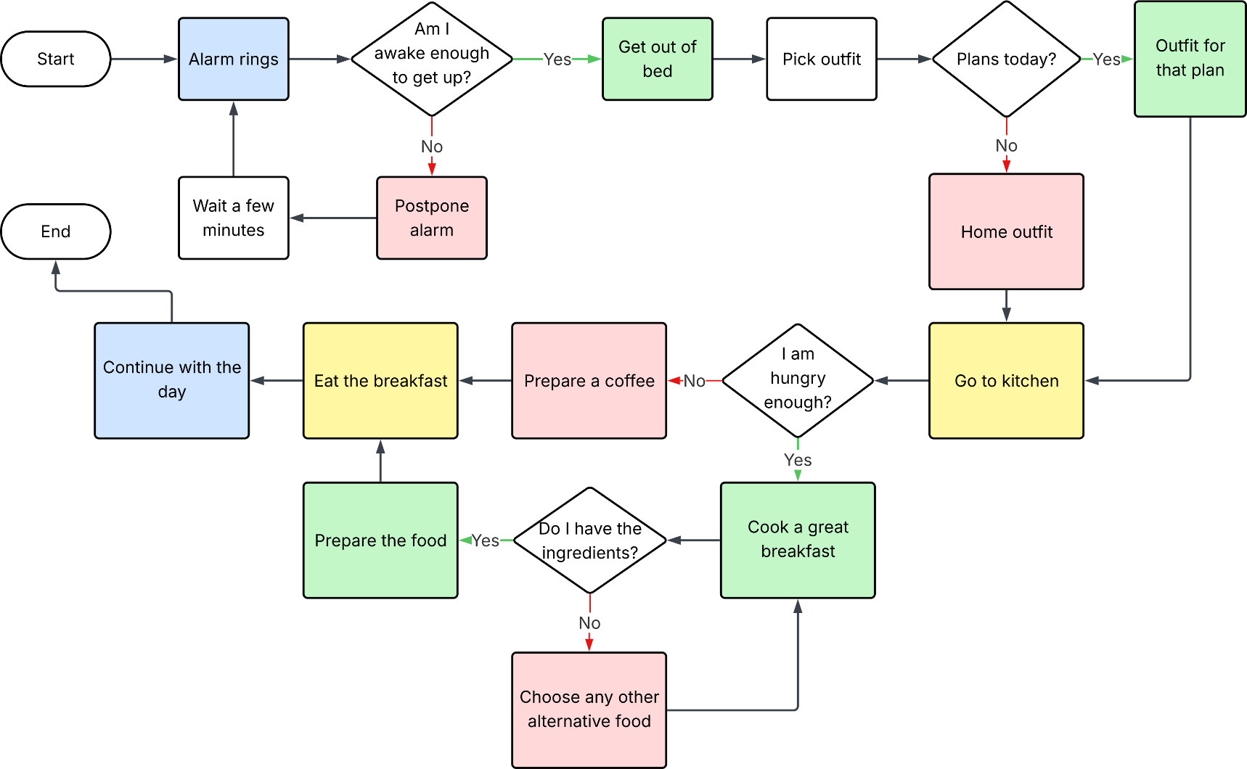
The flowchart begins with the alarm going off. A snooze decision loop is modeled with a condition that checks whether "enough is enough" the vague, subjective threshold required to finally rise. Once up, the process branches into picking an outfit (with a decision on whether it looks good, looping back if not) and then choosing breakfast based on both mood and available ingredients. The diagram terminates upon leaving for the day.

Figure 1. Flowchart depicting the morning starting routine.

2.2 Task 2 - Preparing Tea Flowchart
Task description: Create a flowchart describing the steps required to brew a cup of tea for another person. The flowchart must account for whether the person prefers sugar in their tea.
The process begins by boiling water. Once the kettle is ready, a tea bag is placed in a cup and the water is poured. After steeping for the appropriate time, the tea bag is removed. A decision node then checks whether the recipient takes sugar: if yes, sugar is added and stirred; if not, the cup is served as-is. The diagram concludes once the tea is delivered.
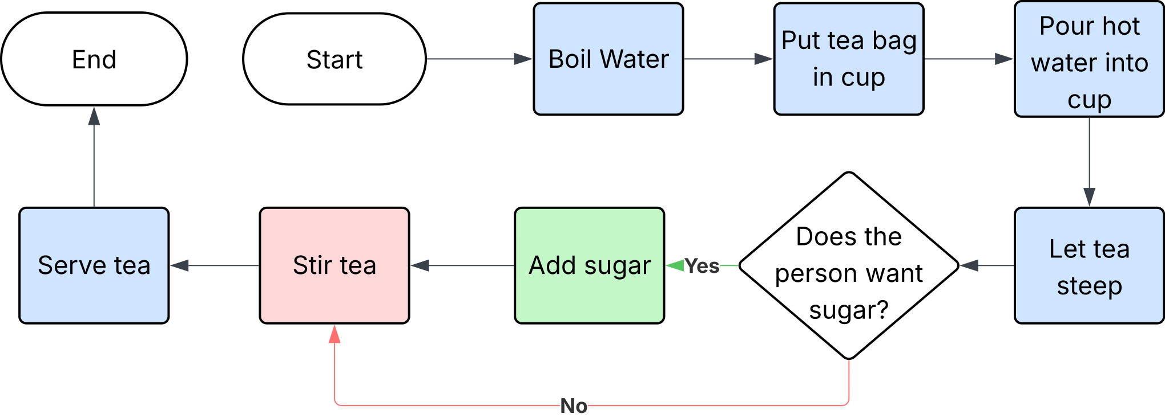
Figure 2. Flowchart for brewing a cup of tea, accounting for sugar preference.

2.3 Task 3 - Post-Murder Decision Flowchart
Task description: A person has been murdered and is lying dead in front of you. Create a flowchart describing the decision-making process based on at least 4 factors, such as: personal safety, being in public, having a phone to call the police, the victim's wallet contents, and whether the responder is the murderer.
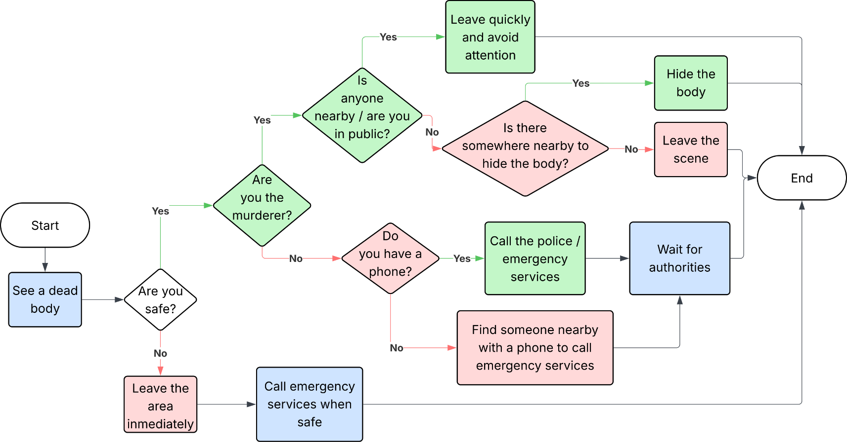
This flowchart models a morally complex scenario using a decision-tree structure. The first check is personal safety: if not safe, the process branches directly to fleeing the scene. If safe, the next check determines whether the situation is public or private. From there, the flowchart evaluates phone availability to call emergency services. A further branch explores whether the responder is themselves the murderer. Additional decision nodes cover practical considerations such as available cash and proximity of a hiding place. All branches eventually converge on a terminal outcome, either involving the authorities or not.

Figure 3. Flowchart of decision-making upon discovering a murder victim.

3. Summary

3.1 Software Suitability Assessment
Lucidchart proved to be highly suitable for the purposes of this laboratory. All three exercises were completable within the free tier without any restriction on the diagramming capabilities required. The tool supports standard flowchart notation including terminators (rounded rectangles), process steps (rectangles), decision diamonds, and connectors with labels - all the elements needed to complete the assigned tasks. Its suitability is further supported by the fact that diagrams can be easily exported to SVG and PNG for inclusion in reports.

3.2 Evaluation of Software Functionality
The functionality of Lucidchart covers all must-have and should-have requirements identified in the comparative feature analysis. Version history, collaboration, and AI tools are accessible at the free or paid tier. The AI diagram generation feature, while not used in this exercise, represents a meaningful differentiator. One limitation is that the free plan caps diagram count at three, which may be constraining for heavier users. Otherwise, functional coverage was complete for this lab.

3.3 User Interface Evaluation
The Lucidchart user interface is clean and well-organized. The left panel provides shape libraries, and shapes can be added either by dragging onto the canvas or by hovering over connector arrows to auto-insert. The toolbar is minimal and non-cluttered. Text formatting, shape resizing, and connector routing all work intuitively. The grid and alignment snapping tools assist in producing tidy diagrams. One area for improvement is discoverability of advanced features such as custom shape libraries, which require some exploration to find.

3.4 Evaluation of Other Software Attributes
Several additional attributes make Lucidchart a strong choice for academic and professional settings:
- Performance: The browser-based application loads quickly and handles moderately complex diagrams without lag.
- Cross-platform Compatibility: Because it runs in any modern browser, it is equally accessible on Windows, macOS, and Linux without any platform-specific issues.
- Export Formats: Diagrams can be exported as PNG, JPEG, PDF, SVG, or Visio (.vsdx), providing broad compatibility with reporting tools.
- Pricing: At approximately $7.95/month for the individual plan (per unofficial sources), it is one of the most cost-effective fully-featured options in the comparison.
- Learning Curve: The tool can be used productively within minutes, making it accessible for first-time users as well as students returning from prior exposure.
Overall, Lucidchart is a well-rounded, accessible, and capable tool for business process modeling. It satisfies all the requirements outlined in the course specification and provides a comfortable working environment for producing professional-quality flowcharts. It is recommended as the primary tool for future modeling exercises in this course.

